Computer Science

Pre-Release 2019

Name:

Year group:

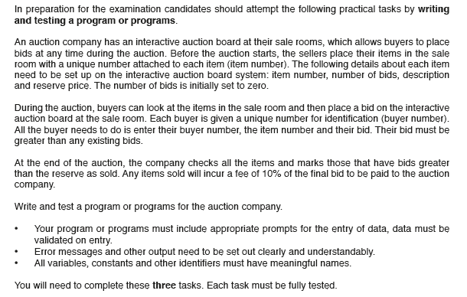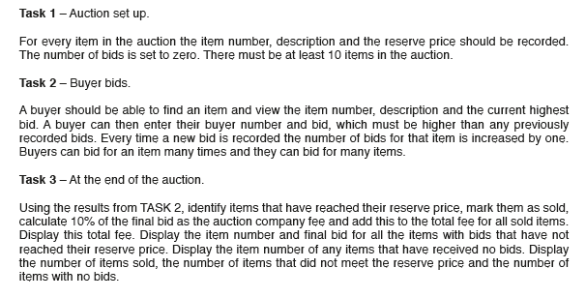

**TASK 1 - Pseudocode**

Const n= 10 // no. of items

WHILE n<10 do // Validation 1 on number of Items

Output “cannot have items less than 10, renter item numbers”

Input n

End While

DECLARE itemno[n] as String

DECLARE Desc[n] as String

DECLARE RP[n] as Integer or Real

DECLARE Bids[n] as Integer

For i <- 0 to n-1

OUTPUT “Enter the item number “

INPUT itemno[i]

For j <- 0 to i-1 // Validation2 on Item no. Unique Number

While( itemno[i] = itemno[j]) Do

OUTPUT “ Error, Duplicate Value, Enter Item No again”

INPUT itemno[i]

EndWhile

Next j

OUTPUT “Enter the description of the item “

INPUT Desc[i]

OUTPUT “Enter the Reserve Price “

INPUT RP[i]

While RP[i]<=0 do //Validation 3

Output “ Cannot be less than 0”

Input RP[i]

End While

Bids[i]<-0

Next i

**TASK1 - Python Code:**

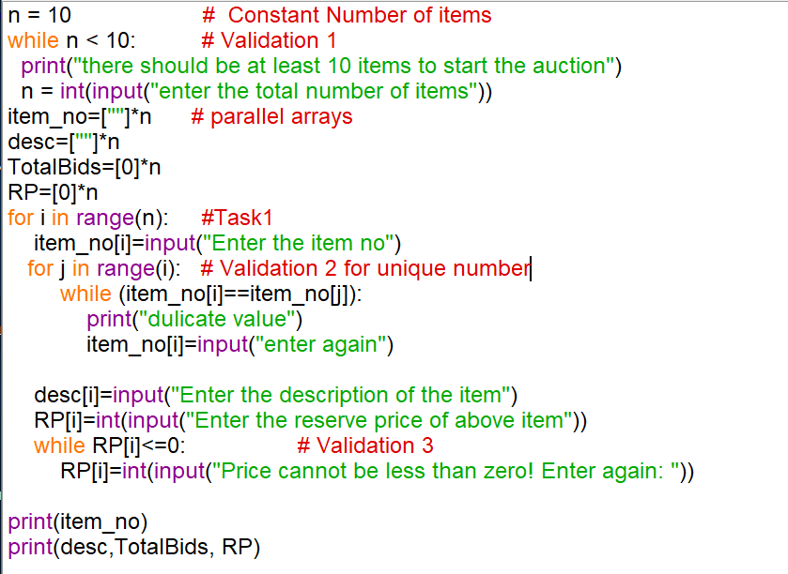

**Draw Flowchart of Task 1**

**TASK 2:**

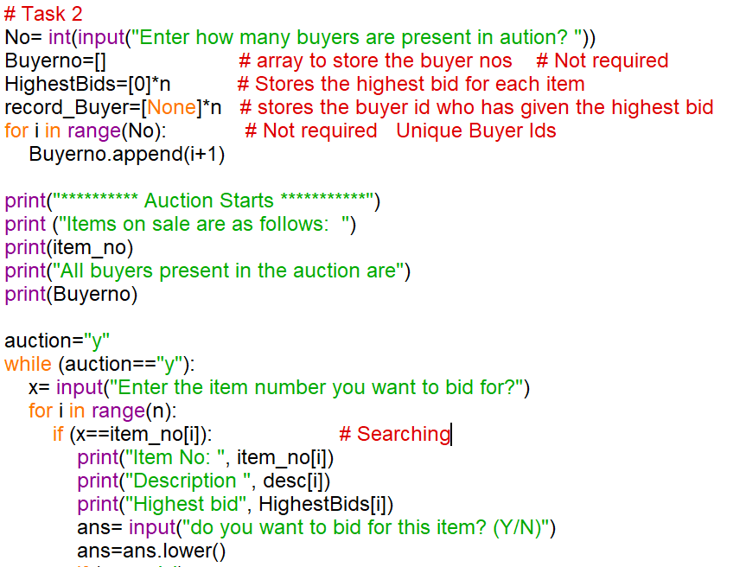

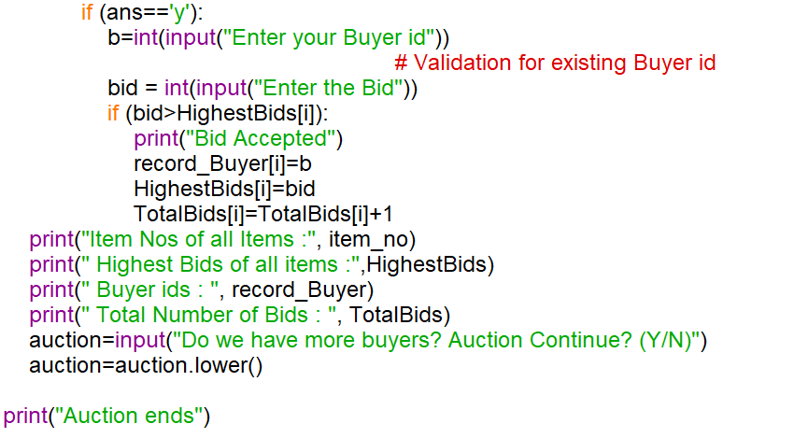

**Pseudocode ( TASK 2):**

**Output “ How many Buyers in the auction”**

**Input No // INTEGER - Constant**

**DECLARE Buyerno[No] : String // DECLARE BuyerNo[0:No-1] as String**

**DECLARE HighestBids[n]: Integer**

**DECLARE record_buyer[n]: String**

**For I <- 0 to No-1**

**Buyerno[I] <- I+1**

**~~END FOR~~ NEXT I**

**Auction<- “Y” // String**

**While (Auction=”Y”) Do**

**OUTPUT “ Enter the item Number, you want to Bid for”**

**INPUT X // STRING, Integer**

**For I<- 0 to N-1**

**IF X=itemno[I] then // Search**

**OUTPUT (“Item No”, itemno[I])**

**OUTPUT (“Description is “, DESC[I])**

**OUTPUT(“Highest Bid for this item is “, HighestBids[I])**

**OUTPUT (“Do you want to Bid for this item?(Y/N)”)**

**INPUT ans // CHAR**

**IF ans=’Y’ Then // Bid**

**OUTPUT ( “Enter the Bid”)**

**INPUT bid // Integer, REAL**

**IF bid > HighestBids[I] then // HighestBid**

**OUTPUT “ Bid Accepted”**

**OUTPUT “ enter the Buyer No”**

**INPUT B // INTEGER**

**HighestBids[I] = bid**

**Record_buyer[I]= B**

**Bids[I] = Bid[I]+1**

**END If // End of HighestBid**

**End IF // End of Bid**

**END IF // End of Search**

**For P<- 0 to N-1 // To display**

**OUTPUT “ Item No”, itemno[P]**

**OUTPUT “ Highest Bid”, HigestBids[P]**

**OUTPUT “ BuyerId with Highest Bid “, record_buyer[P]**

**OUTPUT “ No. of Bids”, Bids[P]**

**~~END FOR~~ NEXT P**

**E~~nd FOR~~  NEXT I**

**Output “ Do you want to continue?”**

**Input Auction**

**END While**

**Flow Chart (Task 2)**

**TASK 3:**

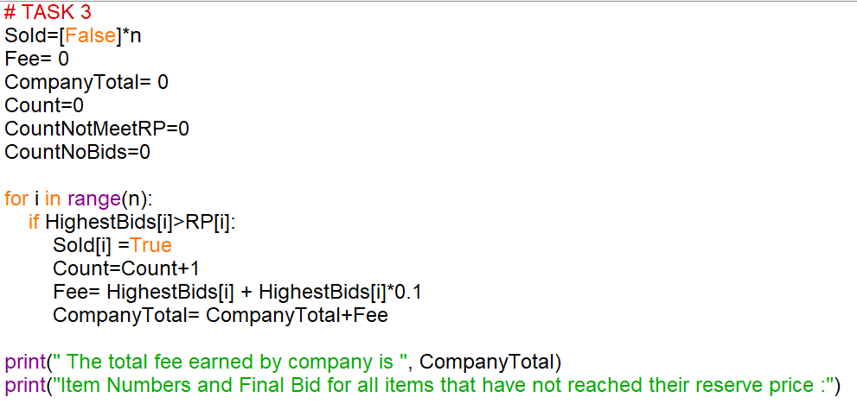

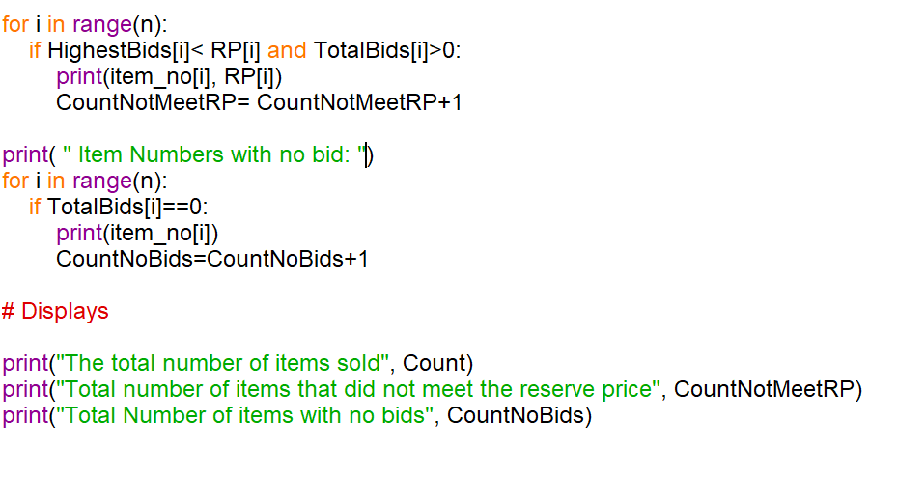

**Pseudocode:**

**Flowchart (Task 3):**

**Question Answers: (Refer TASK 1)**

**Q1 : Define constant. Identify all constants used in your program.**

**Q2 : Define variable. List three variables used in your program with their data types and purpose.**

**Q3 : What is a data structure? List the data structure used in your program and give one example.**

**Q4 : List the data type of all arrays used in Task 1. State why have you chosen the listed data type.**

**Q 5 a) What is the difference between validation and verification? List validations used in the code with its purpose.**

**Q5 b) What is an identifier?**

**(Refer TASK 2)**

**Q6 Write pseudocode to check whether the given buyer number exists or not.**

**Q7 What is a counter? Identify counters used in your code. ( All TASKs)**

**Q8 Identify the code where counting is done. ( Task 2 and Task 3)**

**Q9 What is the difference between counting and totaling? (Task 2 and Task 3)**

**Q10 Identify code in Task3 that represent totaling and counting.**

**Q11 List basic data types**.

**Q12 Write any iteration and selection examples from the pseudocodes of Task1 and Task 2.**

**Q13 What are parallel arrays? Explain with example.**

**Q14 Explain why array is an effective data structure to store data.**

**Q15 Write pseudocode to display all item numbers which are sold.**

**Q16 Write pseudocode to display item numbers, the highest bid and buyer number of all sold items.**